Course code : TECH1101
Semester/Year : Fall 2017
Assignment code: GLA1
Author : Scott B Patterson
ID : 381528
Date created : 2017-09-18
Description :Fun times

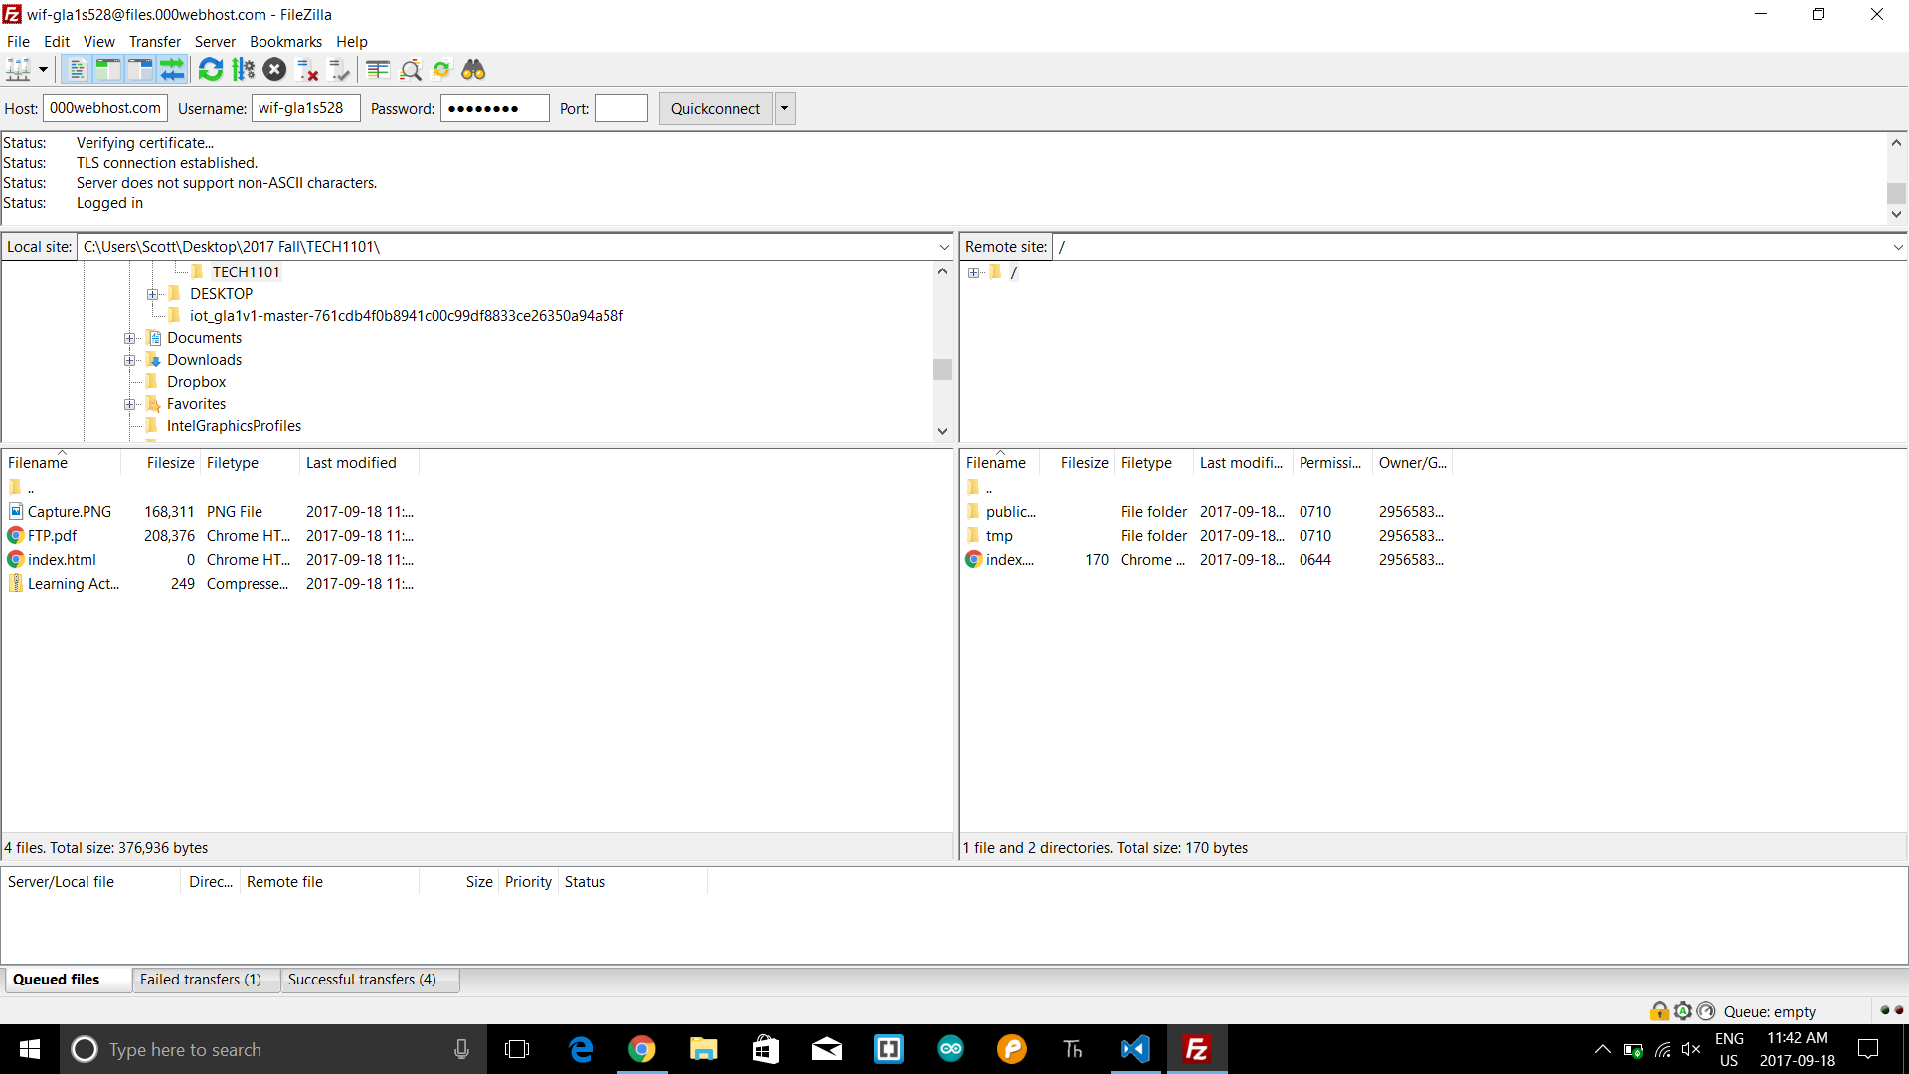

https://wif-gla1s528.000webhostapp.com

https://ide.c9.io/spatterson528/wif_gla1_s528

